

Sample Software Architecture Document

#AGiveAwayApp

SAD Revision History

Date | Version | Description | Author
2005-03-16 | 0.1 | Significant Use-Cases : the key requirements | Crescent  Architecture Team
2003-03-18 | 0.2 | Candidate architecture : the high level architecture of the system | Crescent  Architecture Team
2003-03-20 | 0.3 | Initial Deployment Model | Crescent  Architecture Team
2003-04-24 | 0.4 | Key abstractions : the key data elements used in the system | Crescent  Architecture Team
2003-04-29 | 0.5 | Analysis Model | Crescent  Architecture Team
2003-05-05 | 0.6 | Design Model | Crescent  Architecture Team
2004-05-11 | 0.7 | Concurrency mechanisms | Crescent  Architecture Team
????-??-?? | 0.8 |  | Crescent  Architecture Team

Table of Contents

1. Introduction 4
1.1 Purpose 4
1.2 Scope 5
1.3 Definitions, Acronyms and Abbreviations 5
1.4 References 5
1.5 Overview 5
2. Architectural Representation 6
3. Architectural Goals and Constraints 7
3.1 Technical Platform 7
3.2 Transaction 7
3.3 Security 7
3.4 Persistence 7
3.5 Reliability/Availability (failover) 7
3.6 Performance 8
3.7 Internationalization (i18n) 8
4. Use-Case View 8
4.1 Ordering Menus 8
4.2 Use-Case Realizations 9
5. Logical View 9
5.1 Overview 9
5.2 Architecturally Significant Design Packages 11
6. Process View 13
7. Deployment View 13
8. Implementation View 15
8.1 Overview 15
8.2 Layers 15
9. Data View 15
10. Size and Performance 16
11. Quality 16

Introduction
This document comes as a complement to the article “Developing a J2EE Architecture with Rational Software Architect using the Rational Unified Process®” [RUPRSA]. It illustrates what can be the content of a Software Architecture Document (SAD) produced during the RUP Elaboration phase.
As stated in the companion article, a RUP Software Architect will typically perform height major steps in order to define a global architecture, and each time an activity is completed, a specific section of the SAD is enriched accordingly.

Architectural activities | Software Architecture Document
Step 1 - Identify and prioritize significant Use-Cases | Section 4
Step 2 - Define the candidate architecture | Section 3, 5.1, 10, 11
Step 3 - Define the initial Deployment Model | Section 7
Step 4 - Identify key abstractions | Section 9
Step 5 - Create an Analysis Model | Section 5
Step 6 - Create the Design Model | Section 5
Step 7 - Document concurrency mechanisms | Section 6, 7
Step 8 - Create the Implementation Model | Section 8

Purpose
The Software Architecture Document (SAD) provides a comprehensive architectural overview of the Online Platform for donating items to the needy offered by Crescent It presents a number of different architectural views to depict different aspects of the system. It is intended to capture and convey the significant architectural decisions which have been made on the system.

In order to depict the software as accurately as possible, the structure of this document is based on the “4+1” model view of architecture [KRU41].

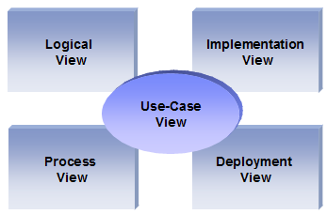
The “4+1” View Model allows users to understand what it’s all about ,how will it work and who will be involved.

Scope
The scope of this SAD is to depict the architecture of the online Platform for donating items created by the company Crescent

Definitions, Acronyms and Abbreviations

RUP: Rational Unified Process
UML: Unified Modeling Language
SAD: Software Architecture Document

References

[KRU41]: The “4+1” view model of software architecture, Philippe Kruchten, November 1995, http://www3.software.ibm.com/ibmdl/pub/software/rational/web/whitepapers/2003/Pbk4p1.pdf

[RUPRSA]: Developing a J2EE Architecture with Rational Software Architect using the Rational Unified Process®, IBM DeveloperWorks, Jean-Louis Maréchaux, Mars 2005, http://www-128.ibm.com/developerworks/rational/library/05/0816_Louis/

Overview

In order to fully document all the aspects of the architecture, the Software Architecture Document contains the following subsections.
Section 2: describes the use of each view
Section 3: describes the architectural constraints of the system
Section 4: describes the functional requirements with a significant impact on the architecture
Section 5: describes the most important use-case realization. Will contain the Analysis Model and the Design Model
Section 6: describes design’s concurrency aspects
Section 7: describes how the system will be deployed. Will contain the Deployment Model
Section 8: describes the layers and subsystems of the application
Section 9: describes any significant persistent element. Will contain the Data Model
Section 10: describes any performance issues and constraints
Section 11: describes any aspects related to the quality of service (QoS) attributes

Architectural Representation

This document details the architecture using the views but using the RUP naming convention. The views used to document the Crescent application are:

Logical view
Audience: Application Administrators.
Area:
Functional Requirements:
- The first administrator user can login, and view the admin user creation dashboard as well as inventory details dashboard. The first user can create other Application Administrator users.
- Administrator User can have the option to see list of users belonging to different role.
- They can accept/reject the request.

Related Artifacts: Design model

Process view
Audience: Volunteering User, Outreach Volunteer, Application Administrators
Area: Non-functional requirements:
- Describes the design's concurrency and synchronization aspects.
- First the User can request for providing the items so that admin process can process it and later the outreach volunteer will pick those items to get it distributed among the needy. At each phase users will be getting notification (via-email) regarding the status.
Related Artifacts: Flow Diagrams (I Showing Item Requests-Item Approval, Inventory Updation, Mail Updates etc.)

Implementation view
Audience: Administrators.
Area: Software components: describes the layers and subsystems of the application.
Related Artifacts: Implementation model, components

Deployment view
Audience: Deployment managers.
Area: Topology: describes the mapping of the software onto the hardware and shows the system's distributed aspects.
Related Artifacts: Deployment model.

Use Case view
Audience: all the users including the end-users.
Area:
Describes the set of scenarios that represent some significant, central functionality of the system.
Users login , Request and approval, Mail generation at each process, Inventory Updation

Related Artifacts : Use-Case Model, Use-Case documents

Data view (optional)
Audience:, Database administrators
Area: Persistence: describes the architecturally significant persistent elements in the data model
(Items like-Book,Lab Kids specifications)
Related Artifacts: Data model.

Architectural Goals and Constraints

This section describes the software requirements and objectives that have some significant impact on the architecture

Technical Platform

The Crescent Online Give Away Application will be deployed onto a J2EE application server (Websphere Application Server version 6, as it is already the application server use for internal applications).

Transaction

The Crescent Online Give Away Application is the technical platform capabilities that aims to provide engagement programs where interested users can volunteer for Outreach events. The engagement platform offered by this application adds a features of offering items handed to Collection/Inventory Centers ,later picked by Outreach Volunteers .A Online Item management model of the J2EE platform will be reused intensively.

Security

The system must be secured, so that a customer can make online payments.
The application must implement basic security behaviors:
- Authentication: Login using at least a user name and a password
- Authorization: According to their profile, User must be granted or not to perform some specific actions (Application administrators perform, Volunteers etc.)
For internet access, the following requirements are mandatory
- Confidentiality: Data must be encrypted (Passwords)
- Data integrity : Data sent across the network cannot be modified by every user
- Auditing: Every action(requests) can be logged
- Non-repudiation : gives evidence a specific action occurred
J2EE security model will be reused

Persistence

Data persistence will be addressed using a relational database.

Reliability/Availability (failover)

The availability of the system is a key requirement by nature, as it is a donating system to one who are in a need. The candidate architecture must ensure fail over capabilities. Reliability/Availability will be addressed through the J2EE platform
Targeted availability is 16/7: 24 hours a day, 7 days a week
From DB End will check for for any maintenance activities on regular basis.

Performance

Use-Case View

This section lists use cases or scenarios from the use-case model if they represent some significant, central functionality of the final system. The only use-case with a significant impact on the online is the one related to online orders. It includes a search feature as well as a call to external services (delivery and payment)

Application Administrators:

- There will be one hard coded administrator user credentials in the database. Using this credentials, the first administrator user can login, and view the admin user creation dashboard as well as inventory details dashboard. The first user can create other Application Administrator users.
- Application Administrator User will have option to see list of users belonging to different role. Administrator will be playing the vital role in maintaining the application as they have the right to deactivate the user based on violations of code of conduct.
- Application Administrator users can approve/reject item collection requests from inventory by Outreach Volunteering user. An email with details will be sent to the Outreach Volunteer user. If approved, the Outreach Volunteering User can collect requested items from Inventory/Collection Centre for the distribution to the needy.
- Application Administrator users can check status of items in Inventory/Collection Centre and can do necessary updates.
- Application Administrator users can generate several reports:
  - Report for items collected in inventory for a particular Collection Centre during a time span.
  - Report for any Outreach Volunteer User on what all request/work has been done by the Outreach Volunteer User during a time span.
- Application Administrator Users only will have access to DB where necessary update can be done as per the need of the application.

- Application Administrator users can post updates about Engagement programs being organized by Outreach.

4.2 Volunteering User:
- Volunteering users will sign-up for this application and post registration they will be able to put in requests for offering their belongings to needy. Account for Volunteer Users will be activated instantly
- At the time of request on the website, the user will have to fill in details about their belonging along with their pictures clicked by them. The user has option to select at which Collection/Inventory Centre they will submit their belongings.
- These requests can be approved/rejected by application administrators. Once their requests are approved upon scrutiny, they will get a mail mentioning date-time frame during which they can submit their belonging. User can view from their dashboard, the list of offering requests they have placed and their current status.

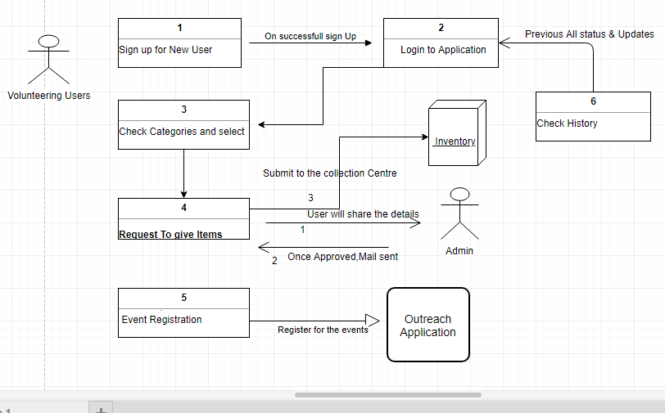

4.3 Outreach Volunteers

- Outreach Volunteer users will sign-up on the application. Upon activation of their account, they will be able to login into the application. The activation of Outreach volunteer user’s accounts will be done by Application Administrators. Upon activation, Outreach Volunteer user will get an intimation using email.
- Once Outreach Volunteer logs into the application, user will be able to see the dashboard made specifically for Outreach Volunteer users.
- They can view Inventory details and can place request for items in inventory as per the needs they have analyzed and for which they will be volunteering. These requests for items need to be approved by Application Administrators.
- Once item requests are approved, inventory status would be updated, and so will the request status for the Outreach Volunteering user. Outreach Volunteering user will be intimated via email
- Outreach volunteering users can view list of requests made by them, and their current status in their dashboard.
- Outreach Volunteer users can also put in requests for offering their belongings to needy, the same way like a Volunteering User has option to do.
- Outreach Volunteer user can generate report based on the list of requests they have worked upon and which all people/NGOs have benefited from his work

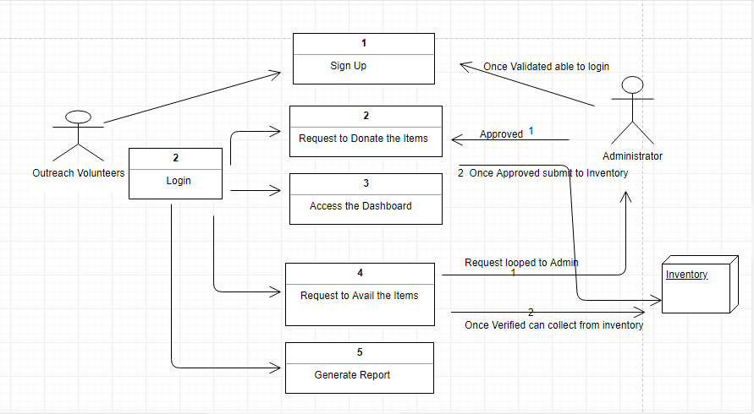

5. Use-Case Realizations

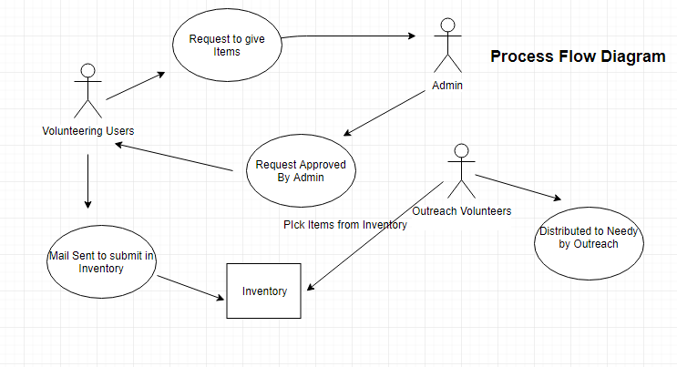
Refers to section 5 to see how design elements provide the functionalities identified in the significant use-cases.

Logical View

Overview

The Online Give Away Application is divided into layers based on the N-tier architecture
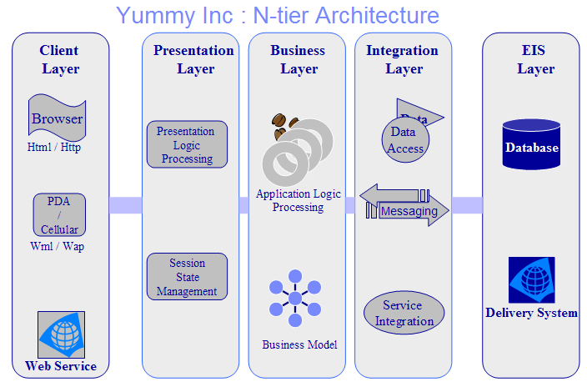

The layering model of the Online Give Away Application is based on a responsibility layering strategy that associates each layer with a particular responsibility.
This strategy has been chosen because it isolates various system responsibilities from one user to another, so that it improves both system smooth processing and maintenance from admin ends

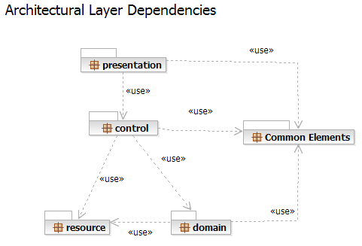

Each layer has specific responsibilities.
- The presentation layer deals with the presentation logic and the pages rendering
- The control layer manages the access to the domain layer
- The resource layer (integration layer) is responsible for the access to the Inventory system (databases or other sources of information)
- The domain layer is related to the business logic and manages the accesses to the resource layer.
- The Common Elements layer gathers the common objects reused through all the layers

The Online Give Away Application version 1.0 is quite simple and only contains two basic features, one for requesting to give the belongings (Books mainly) and the other allowing to collect form Inventory and giving to the needy.
External services in our future scopes like Providing Study material along with books, requesting to give items and buying them online and getting it delivered to the Inventory itself.

Architecturally Significant Design Packages

Menus

This package is responsible for all the logic related to the Give Away Application. It provides giving belongings features and the necessary components to access the dashboard, request and get it approved.

Analysis Model

Basic Flow:

Design Model

Delivery Service

Process View

There’s only one process to take into account. The J2EE model automatically handles threads which are instances of this process.

Deployment View

Global Overview
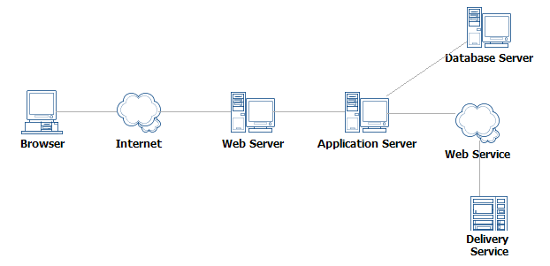

Detailed deployment model with clustering

- One IBM HTTP Server will dispatch requests to two different IBM WebSphere servers (load balancing + clustering)
- An IBM DB2 Database stores all the information related to online orders

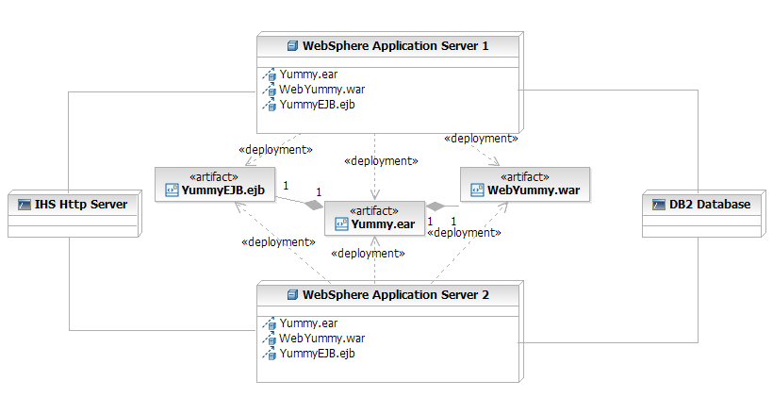

Implementation View

Overview

The Implementation view depicts the physical composition of the implementation in terms of Implementation Subsystems, and Implementation Elements (directories and files, including source code, data, and executable files).
Usually, the layers of the Implementation view do fit the layering defined in the Logical view

It is unnecessary to document the Implementation view in great details in this document. For further information, refer to the Online Catering Service 1.0 workspace in Rational Software Architect.

Layers

Presentation Layer
The Presentation layer contains all the components needed to allow interactions with an end-user. It encompasses the user interface

Control Layer
The Control layer contains all the components used to access the domain layer or directly the resource layer when this is appropriate.

Resource Layer
The Resource layer contains the components needed to enable communication between the business tier and the enterprise information systems (Database, external services, ERP, etc…)

Domain layer
The Domain layer contains all the components related to the business logic. It gathers all the subsystems that meet the needs of a particular business domain. It also contains the business object model.
.

Common Elements Layer
The Common Element layer contains the components re-used within several layers.

Data View

The key data elements related to the Crescent Online Give Away Application are:

Size and Performance

Volumes:
- Estimated Online Request: 5 a day
- Crescent Registered Individual customer : about 20
- Crescent Corporate Users: about 100

Performance:
- Time to process the request by Admin for the items given by Volunteering User.
- Time to communicate with Inventory and Outreach Volunteers.

Quality

As far as the Online Give Away Application is concerned, the following quality goals have been identified:

Scalability:
- Description : System’s reaction when user demands increase
- Solution : J2EE application servers support several workload management techniques
Reliability, Availability:
- Description :
- Solution : : J2EE application server supports load balancing through clusters
Portability:
- Description : Ability to be reused in another environment
- Solution : The system me be fully J2EE compliant and thus can be deploy onto any J2EE application server
Security:
- Description : Authentication and authorization mechanisms
- Solution : J2EE native security mechanisms will be reused

